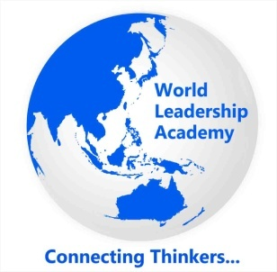

- Title of your proposed book:

- Author/editor information (Name, Affiliation, Address, Email ID, Mobile Number) :

- Please provide a technical description of the project (at least 5 paragraphs) and what this book is about. (Aim and scope.)

- Please provide at least three (3) competitive books of other publishers, supplying as much information as possible. Competition can be found on amazon.com or the Publisher’s respective website.

- List at least five (5) specific selling features and key benefits of your book. Along with the strengths of your book, these are the aspects of your book that will make the reader excited to purchase it – list features that you feel would encourage a customer to select your book over a competitor.

- Target audience of your book:

- Table of contents - Please provide here the planned content of your book, including chapter titles and a short paragraph or bullet points on the scope/initial content plan for each chapter (max 100 words).

- When will the manuscript be considered complete and ready to be sent to WLA Press to enter production?

- Please add any other information that you think might be helpful to us in evaluating your proposal.

Please return to:
Dr. Brojo Kishore Mishra
Series Editor - Emerging Technologies for Sustainable Development
World Leadership Academy
brojomishra@gmail.com / +91 - 9437875808

